Wind Speed Sensor (NPN-PNP-NPNR)

ZTS-3000-FSJT-*
Ver 2.0

Catalogue
Chapter 1 Product Introduction 3
1.1 Product Overview 3
1.2 Functional features 3
1.3 Main parameters 3
1.5 Product selection 4
Chapter 2 Hardware Connection 5
2.1 Inspection before equipment installation 5
2.2 Interface description 5
2.2.1 Sensor wiring 5
2.3 Installation method 5
2.4 Notes 6
Chapter 3 Instructions for use 7
3.1 Output circuit diagram 7
3.2 Pulse output calculation 8

Chapter 1 Product Introduction

1.1 Product Overview
PR-3000-FSJT-* wind speed transmitter (pulse type) is small and light, easy to carry and assemble. The three-cup design concept can effectively obtain wind speed information. The shell is made of polycarbonate composite materials, which has good anti-corrosion, anti-erosion and other characteristics, which can ensure the long-term use of the transmitter without rust. At the same time, with the internal smooth bearing system, the accuracy of information collection is ensured. It is widely used in wind speed measurement in greenhouses, environmental protection, meteorological stations, ships, docks, aquaculture and other environments.

1.2 Functional features
- Range: 0-70m/s, resolution 0.0875m/s
- Anti-electromagnetic interference treatment
- Adopt the bottom out-of-line method to completely eliminate the aging problem of aviation plug rubber pad, and it is still waterproof after long-term use.
- Adopt high-performance imported bearings with small rotational resistance and accurate measurement
- Polycarbonate shell, with high mechanical strength, high hardness, corrosion resistance and rust-free, can be used outdoors for a long time.
- The structure and weight of the equipment are carefully designed and distributed, with small rotational inertia and sensitive response.

1.3 Main parameters
DC power supply (default) | 5~30V DC
The working temperature of the transmitter circuit | -40℃~+60℃, 0%RH~80%RH
Communication interface | Pulse output
Resolution | 0.0875m/s
Precision | ± (0.2+0.03V)m/s V represents wind speed
Measuring range | 0~70m/s
Dynamic response time | ≤0.5s
Start the wind speed | ≤0.2 m/s
Load capacity | PNP | ≥100 mA
Load capacity | NPN | ≥100 mA
For long-term use, please keep the ambient wind speed below 30m/s.
Product size:
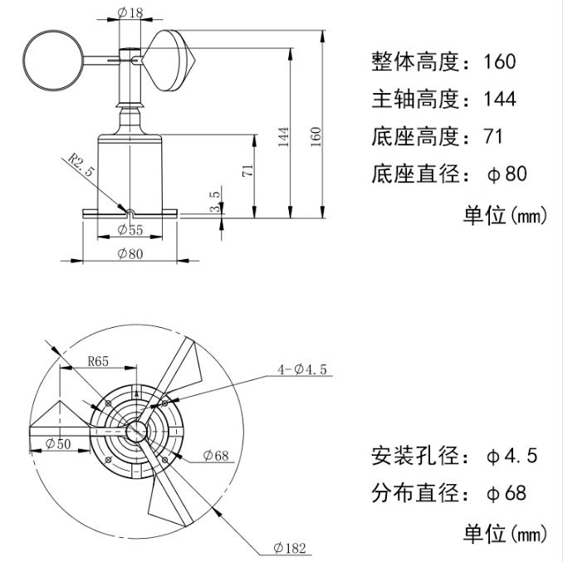

1.5 Product selection
PR- |  |  |  | Company code
 | 3000- |  |  | Shell code
 |  | FSJT- |  | Wind speed transmitter
 |  |  | PNP | PNP output
 |  |  | NPN | NPN output
 |  |  | NPNR | Internal pull resistor NPN output

Chapter 2 Hardware Connection

2.1 Inspection before equipment installation
Equipment list:
■ 1 transmitter equipment
■ 4 screws for installation
■ Qualification certificate, warranty card

2.2 Interface description
The wide-voltage power supply input can be 5~30V.

2.2.1 Sensor wiring
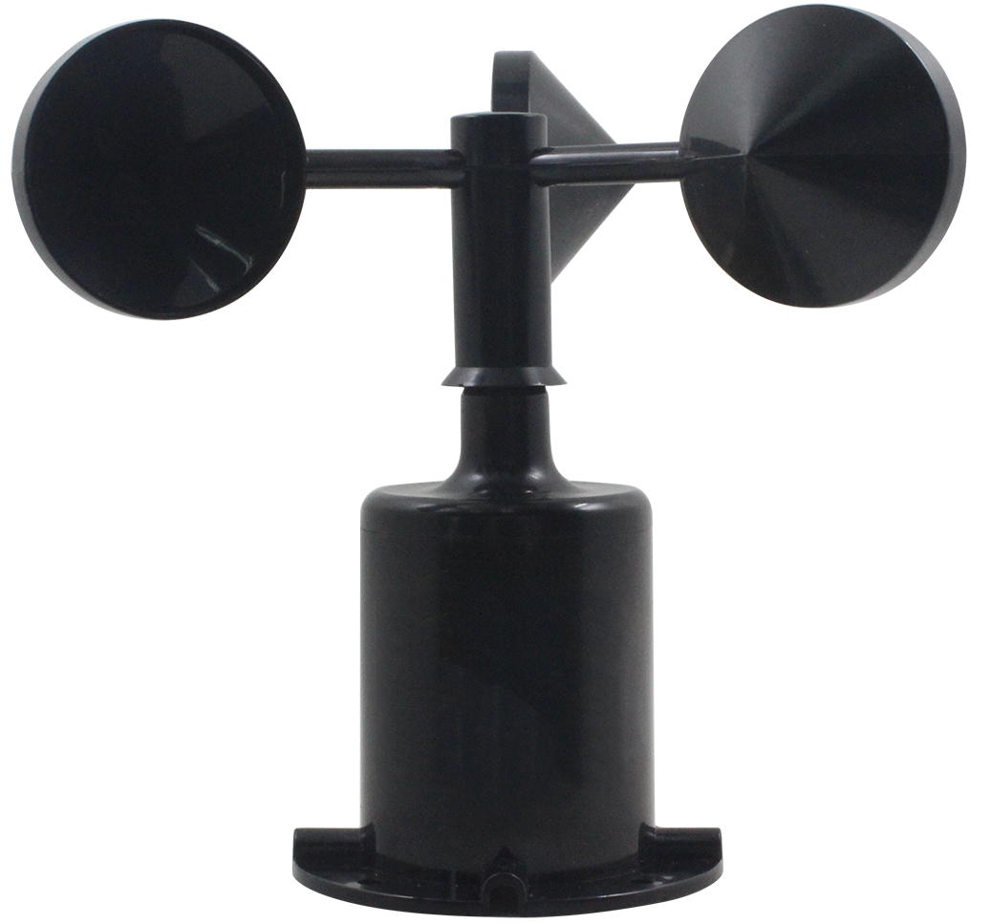

 | Line color | Explain
Power supply | Brown | The power supply is positive (5~30V DC)
Power supply | Black | Negative power supply
Pulse signal | Green | PNPOUT
Pulse signal | Blue | NPN (NPNR) OUT

2.3 Installation method
The flange installation is adopted, and the threaded flange connection makes the lower pipe fitting of the wind speed sensor firmly fixed on the flange. The chassis is Ø80mm, and four mounting holes with an average of Ø4.5mm are opened on the circumference of Ø68mm. The bolts are used to fix it tightly on the bracket, so that the whole set of instruments is kept at the best level and the wind speed is guaranteed. The accuracy of the data, the flange connection is easy to use and can withstand greater pressure. 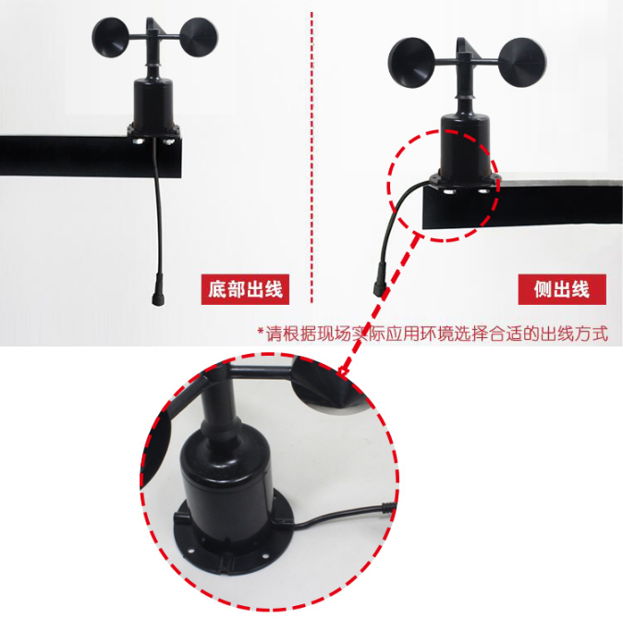

2.4 Notes
1. Users are not allowed to disassemble it by themselves, let alone touch the sensor core, so as not to cause damage to the product.
2. Try to stay away from high-power interference equipment as much as possible to avoid inaccurate measurement, such as frequency converters, motors, etc. When installing and disassembling the transmitter, the power supply must be disconnected first. Water entering the transmitter may lead to irreversible changes.
3. Prevent chemical reagents, oil, dust, etc. from directly affecting the sensor. Do not use it for a long time in condensation and extreme temperature environments, and strictly prevent cold and heat shocks.

Chapter 3 Instructions for use

3.1 Output circuit diagram
The PNP output circuit diagram is as follows: (maximum output current = 100mA)
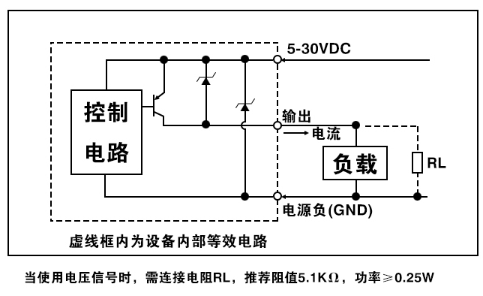
The NPN output circuit diagram is as follows: (Maximum infusion current = 100mA)
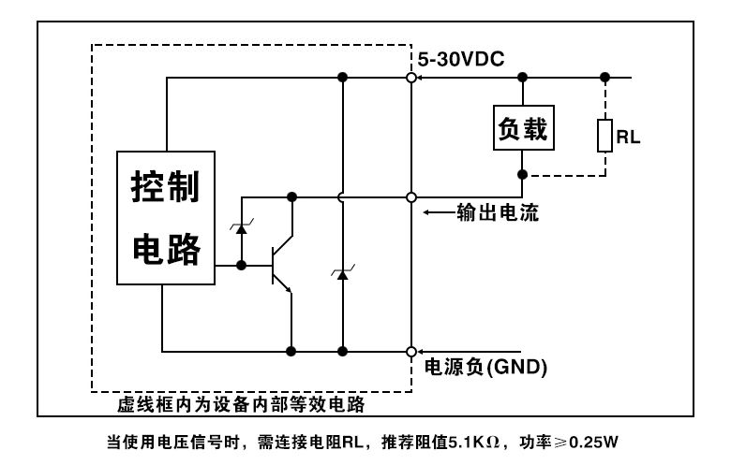
The internal pull resistor NPN output circuit diagram is as follows: (RL=5.1KΩ)
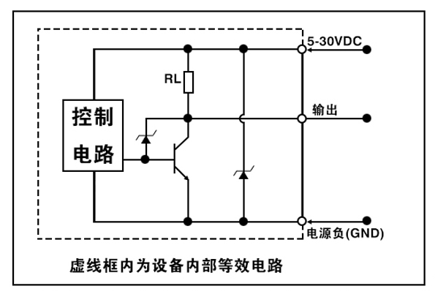

3.2 Pulse output calculation
The transmitter rotates 1 turn and outputs 20 pulses.
For example, when the wind speed transmitter 1S rotates 1 lap, the transmitter 1S outputs 20 pulses, which means that the wind speed is 1.75m/S.

